# Executive Summary:

This game is based on the near future of America where president Trump has a few months in office remaining and his opposition are trying to impeach him. As the impeachment and re-election dates near Donald gets a call threatening to be exposed by using the Russians to help him get into office in the first election and has physical proof as well as witnesses to back it up. Donald responds angrily down the phone to the unknown caller and hangs up. A few months later the threats become real and the information about Donald’s use of the Russians becomes public for everyone to see. This is where the game starts.

After watching this video the players have the choice to play as Donald, Hillary and Obama. Depending on which character is chosen by the player will determine what story ark they will follow.

# Contents:

# Introduction:

## Intended Game Platforms:

The intended game systems I have chosen for this game is smartphones such as Apple, Android and windows as well as consoles such as Xbox and PlayStation. This is due to the estimated amount of players that play games on mobile as well as console being 60% as well as the mobile market global revenue being estimated at $76 billion and console revenue estimated at $30 billion this year. This is shown on figures 1-3 below

Figure 2

Figure 1

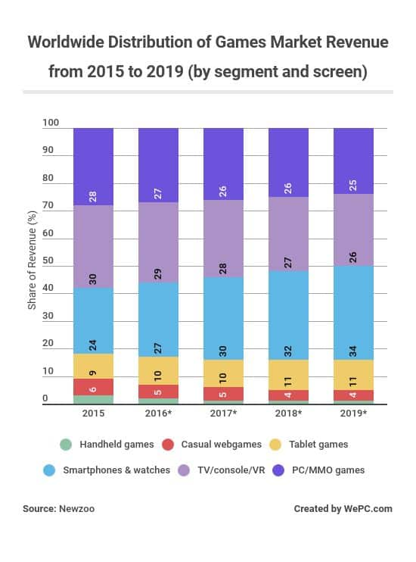

Figure 3

## Target Market & Players:

Players over the age of 16, this is due to the high amount of violence, moderate use of bad language, references towards discrimination and drug usage.

Players who are into single player 3rd person role playing games where they are allowed to customise their character and has a great story/ back story behind the gameplay. Also the genre of gameplay will be very important but I wish to try and make the game content for all types of players such as tactical, explorer and social. This game will also be funny which will help gather players who just want to mess about on games. If some players don’t fall into these brackets I will be including a lot of references towards real world scenarios which will help draw in players who watch the news as well as use social media on a daily basis.



## Game Logo:

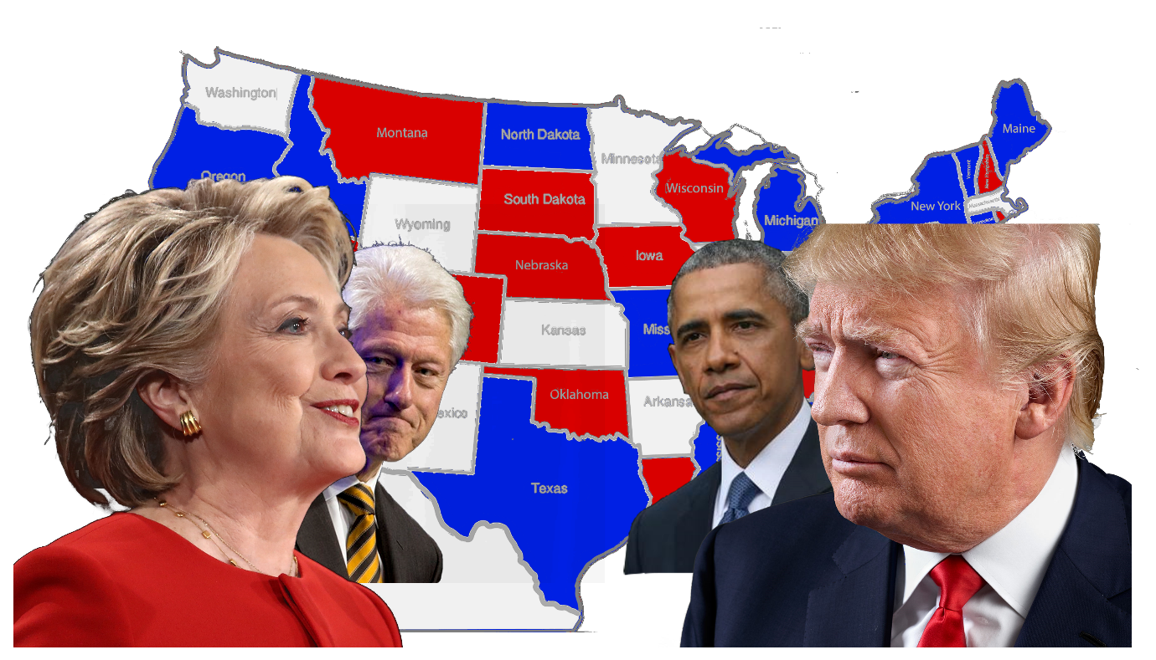

# Game Progression/ Flow & Chart:

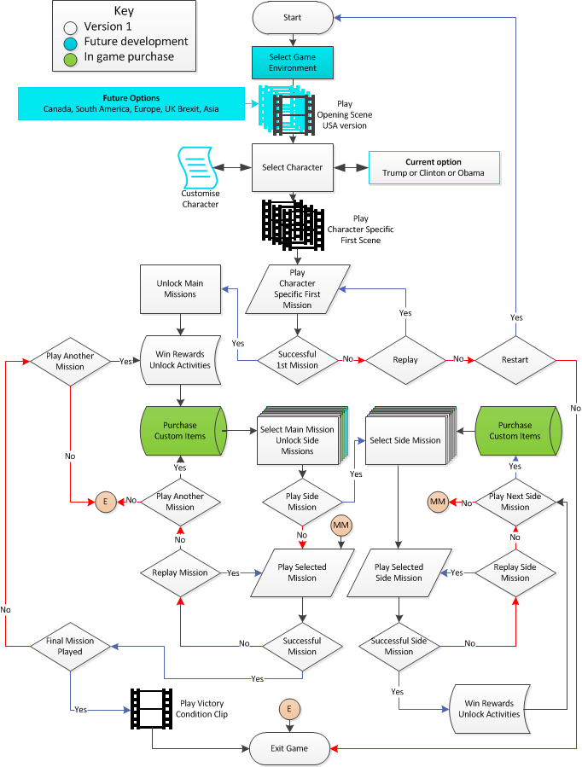

## Progression System

As player’s complete main story and side story missions they are rewarded with experience which goes towards levelling up in the game, weapons related to the mission itself such as a rifle they will win a new rifle and the rarity of the rifle depends on the difficulty of the mission and how well the player did on it. They can also win armour and influence respective of their current traits, goals and what character they are playing as.

Players are also capable of opening loot crates for loyal gameplay such as amount of hours played, signing up to forums about the game and completing story missions and activities. In these loot crates players can find anything from extra experience to legendary weaponry and the chance of getting the better rewards are increased depending of the player’s performances and support.

## Player Challenges

During gameplay the players will encounter several different challenges across the game world and depending on the character they have chosen to play the game as will help them decide how to deal with the current issue at hand. Players will need to adapt to each different situation and goal they need to complete in order win the encounter, this can be a main story mission, side story mission or a free roam activity to help edge the political influence in that certain area on the players parties favour.

## Boss Battles

As players progress through the occupation of an enemy state or city the last stronghold will always hold the governor/ main influencer for the opponents party in that certain state/city. If the players are able to kill or capture depending on who they play as the governor are now in control of that specific city/ state. The governors are equipped with weapons respective of the party they are with. For example if they are with Trump they will have powerful offensive weapons over other rewards.

# Game Characters & Traits:

## Playable Characters (PC’s) & Traits:

### Donald Trump:

Donald is a very aggressive and outspoken character meaning that he doesn’t get along with a lot of people and can easily upset others, however he is a very successful business man meaning he is able to make a lot of deals for man power weapons and resources. He is also capable to bribery towards enemy forces.

Donald’s Traits:

* Very aggressive
* Outspoken
* Discriminative towards others
* Successful business man
* Capable of Bribery
* Access to presidency perks such as national guard and secret service

(Create Photoshop doc to represent this under character design)

### Hillary & Bill Clinton:

Hillary & Bill are just as aggressive as Donald but use their aggression in a different way, they use it politically to encourage other strongholds to yield rather than fight as well as get support from superpowers abroad. This means they don’t have as powerful weapons as Donald’s allies but have access to more variety of weaponry and forms of weapons such as armour and deployable equipment like turrets and drones.

Hillary and Bills traits:

* Politically Aggressive
* Influence Abroad
* Minor Negotiations skills
* Access to heavy armour
* Access to deployable equipment
* (Create Photoshop doc to represent this under character design)

### Barack & Michelle Obama:

Barak and Michelle are not nearly as violently aggressive as the Clinton’s and Donald’s supporters but they do have the support of the healthcare aspects of the country as well as very strong skills in negotiations as well as caring for fallen and wounded enemies. This means that Barak hasn’t got access to very powerful weapons but have a lot more health in battles as well as access to deployable health assets to help allies and extra capability to loot all kinds of resources & weapons.

Barack & Michelle traits:

* Standard weaponry, strong survival skills
* Very strong negotiation skills
* Willing to help any American regardless of beliefs
* Deployable health assets
* Extra look space & capability
* (Create Photoshop doc to represent this under character design)

## Non-Playable Characters (NPC’s):

### Secret Service:

The secret servicemen and women are the president’s personal army equipped with high tech and powerful weaponry. They are capable of defending strongholds very well but due to the lack of armour and direction they are not recommended to be used for assaults, they are also very expensive to recruit and can only be recruited by the presidents character (Donald Trump). They are able to be recruited from anywhere and can provide Donald great cover for his escape is necessary.

### City Based militia:

City based militia can be found in major cities across America where they class themselves as their own independent militia from the state they are in. these militia can consist of standard American women and men, retired police officers, non-professional soldiers and defected soldiers/ people. These soldiers are key for the player’s character to hold to strongholds in cities and states captured during gameplay.

### State Based militia:

State Based militia are exactly the same as city based except they have a more variety of recruits and can be called upon when the player is assaulting an enemy stronghold/ base in the state they are in.

### National Guard Soldiers:

National Guard soldiers are dotted around America in their base of operations. They can be called in to assist the player at any time but depending on how they are influenced in that state/ city against the player to quicker they will arrive to the players position as well as the number of soldiers in that squad. They will be armed with military based weapons which can help the player a lot against the likes of a Donald Trump stronghold.

### American Police:

The American Police are not that much more powerful to the militia but they are very well organised and when called/ recruited by the player to help they are most effective in street battles and door to door raiding. They are also relatively cheap units and can be very effective in numbers. There main weakness is the secret police and National Guard Units.

### Mexican Border Police:

The Mexican border police are all based along the wall that Trump has built to separate America from Mexico. They are all heavily armoured with strong weapons and very hard to negotiate with. However they will never venture into America and also have some lightly guarded areas across the wall that the players can exploit in order to win as Donald. If the player wishes to try and shoot their way through they will need a lot of followers and weapons to do so.

### Mercenaries:

Mercenaries can be recruited by any player at any time for a cost in influence o/ and currency. The players can be anywhere on the map to purchase them to help fight battles offensively or defensively. The drawback to these soldiers is they are mercenaries and can be bought out by your opponents before or during a battle causing the player to have to fight them too. To help prevent this they have traits and if their loyalty is low the player’s suggestion is to not purchase them.

**Try to include Photoshop/ Illustrator designs of all the characters**

**Concept Artwork towards Characters (Include character choice menu):**

# Player Character Customisation

## Beginning of the game:

At the beginning of the game the players get to choose one of the five characters, once they have done that they can visually customise their characters clothing. The players will have access to all sections around the body (upper, middle, lower body and feet). Players can customise their character to personalise it to themselves. They won’t be able to change any facial or body features till later into the game and can be earned as a reward for missions. These features are shown to the player as “locked” so they cannot be selected.

On the customisation menu screen they players can distinctively tell which type of clothing is where by showing them different icons relating to the clothing section they chose. For example an image of hair is hair, glasses are facial accessories, shirt is upper body and trousers are lower body. Once earned, the new features can then be applied to the player’s character in the pause menu.

Upper Body Customisation:

* Selection of hats
* Selection of scarfs
* Selection of Glasses

Middle Body Customisation:

* Selection of Shirts
* Selection of Jumpers
* Selection of Jackets
* Selection of Bags/ Handbags

Lower Body Customisation:

* Selection of Trousers
* Selection of Shorts
* Selection of dresses & skirts

Feet/ Shoes Customisation:

* Selection of shoes

## During walkthrough of the game:

During the game players can earn the features and clothing locked to the player at the start of the game. They can do this by completing side missions given to the player by NPC’s or by clues such as audio recordings as articles found in main missions or free roam. Once the player completes the mission/ activity they will unlock that feature and if they wish can change their character appearance on the pause menu. These rewards include the colour of the features such as hair and eye colour as well as clothing and accessories.

The customisation of the character does not given any buffs, traits, advantages or disadvantages for the player’s character, this is simply to allow the player to personalise the character.

**Include Photoshop, Illustrator designs of these clothing items**

# Game Outline:

## Game Story:

The players will have the opportunity to play as three different political characters when they start the game; these characters are Donald Trump, Hillary Clinton and Barack Obama. All three playable characters have their own story arks and encounter each other at least once in their quest in America. At the beginning of the game the players watch a two minute opening backstory cut scene which shows them what has happened before the start of the game. Once this scene has finished the players then get the opportunity to choose a character they want to play as during the campaign. If Donald Trump is selected the players start by defending the white house, if Hillary Clinton is chosen the player starts as a Clinton soldier attacking the white house and if Barak Obama is chosen they start at home far away from the destruction of Washington.

## Opening Backstory Cut Scene:

Donald Trump is finished taking a very long and important call which ended in some very foul language and some clear elements of anger being expressed. His family and director of the secret service ask what’s wrong, who was on the phone and what was discussed? Trump responds to his family that everything is okay and pulls the director to a private room.

Once the room has been vacated Donald tells the Director that his opponents have allegations towards his about using the Russians whist campaigning for president and have witness’s as well as papers to prove this. They have threatened to make this information public unless he leaves office immediately. Donald calls there bluff and hangs up after a few words of anger where said.

The documents shown and the witness’s statements make it 100% clear that the Russians helped Donald come into power and America goes crazy and demands Donald’s Impeachment. Six Months later America in political civil war due to this matter and the land of the free becomes a warzone.

## Donald Trump’s Starting Story Ark

### Country Divided:

Once the Civil war starts America is divided into lots of different minor factions with different or similar beliefs on how the country should be run and by whom, the three main factions are the ones run and Barack Obama, Hillary Clinton and Donald Trump. The players are then introduced to the game world as Donald who is outfitted with a military grade assault rifle, side arm and body armour outside of the heavily damaged white house in Washington DC.

### The Defence of the White House:

The Director of the secret service approaches his and updates Donald Trump of the situation of the defence of the White House. Trump then has to lead a defence against the attackers formed of minor militia and political opposition in Washington and save the defenders of certain defeat and occupation of the White House.

Once the battle is over Donald investigates who the attackers where and who they are led by. Once Donald finds out who attacked his Iconic house (payments and bank transfers) he gets all the remaining defenders of the white house (secret service men/women and National Guard) and takes them to the predicted location of the enemy stronghold. This then leads to the first main mission of the game.

### Liberation of Washington

After saving the White House Donald takes his forces to attack the main stronghold and influencer of his enemies in Washington. After a bloody battle the stronghold is taken and occupied by Donald and his followers. From this site as well as the White House all remaining resistance towards Donald is cleaned up. Once this has all been done Donald sets his ambitions to discover recon and capture/ kill his political enemies outside of Washington.

## Hillary Clintons Starting Story Ark

### Country Divided

After hearing of Donald Trump’s tampering of the previous election and the proof being validated by the sources providing the information and the witness’s confirming everything being shown to the world Hillary wakes up her husband Bill and immediately started plans to overthrow Donald in Washington. During the six months that followed Hillary and Bill planned an attack on the White House to try and quickly kill Donald and take over the country. They both recruit a mercenary group and citizen militia with basic weapons to attack the White House using Guerrilla tactics.

### The Attack on the White House

After recruiting the small army, Bill Clinton provides information to the militia of secret pathways/ passages into the White House as well as predicted places where not to attack due to the number of forces, this information is given to them when Bill was in power in 1993-2001 so the information arguably is outdated. Nevertheless the small army took this information and assaulted the White House using a nearby stronghold occupied by Clinton enthusiasts. From this stronghold the Clinton strike force which the player a part of will attack the White House severely damaging it which forces Donald Trump to come out of hiding. Clinton’s forces report sightings of Donald and on Clinton’s orders to attack him. These results in defeat and a full scale retreat for Clinton’s forces back to the stronghold.

### Loss on Washington Stronghold

After hearing of the defeat and full retreat of the Clinton Liberators Bill and Hillary’s orders where to gather as much support as they can and defend the stronghold until Bill can come with an invading force to reinforce and take out Donald and his White House forces for good. Unfortunately it was too late so Hillary’s orders where to fight to the last man & woman whist taking out as much Trump supporters as they can. After Donald killed the remaining Clinton influence stationed at the Stronghold Bill gets a call from Donald declaring war on them.

## Barak Obama’s Starting Story Ark

### Country Divided

After hearing of Donald Trump’s tampering of the previous election and the proof being validated by the sources providing the information and the witness’s confirming everything being shown to the world Barak Obama scoffs/ giggles to himself saying he knew it and America is salvageable from his rule. He then tells his wife and kids what has happened and he is going to make a few calls inside Donald’s party as well as party representatives who have resigned or been fired by him. During the next six months Obama calls and meeting with all these politicians and influencers across all of America to start a revolution to save America before it’s too late.

### Saving America

Barak and his wife Michelle make it clear to his allied Politian’s, civilians, mercenaries and soldiers that they do not want to try and find a fight with the opposition but to primarily help wounded during battles and the helpless, almost acting like liberators to try and influence nearby cities, states and its people to the reside through kindness, healthcare and protection rather than brute force and death. Barak’s goals are to save America, not to destroy it in an attempt to kill is opposition. He and Michelle make that very clear to anyone; city and state hat want to join their cause. In the event of capturing an enemy stronghold or major influencers his soldiers are under neutral orders to bring them in for questioning and the opportunity to keep their lives in exchange for information.

# Successful Endings/ Victory Condition for all characters

## Donald Trump’s Victory Condition

Trump is able to break into the Mexican wall defended by Mexican border police and National Guard influenced by either Clinton or Obama and escapes into Mexico where he bribes his way out of trouble and lives the rest of his life under the protection of the Mexican Drug cartels laving America to its own fate.

## Hillary Clinton’s Victory Condition

Hillary and Bill’s Clinton Liberators manage to take over the majority of Donald’s strongholds, Cities and states meaning that they have more influence, troops and resources to find Donald. They find trump in a nuclear grade underground bunker and finally kill him and his remaining major influencers. This means that they have a clear road to Washington and the Presidents seat, the only main opposition being Obama’s party wo aren’t interested in fighting.

## Barak Obama’s Victory Condition

Barak and Michelle manage to convince any surviving members of both Clintons and Trumps armies to lay down their arms and live together without any more destruction and death of the American people. As they campaign across America armies, militias and even mercenaries stop trying to kill each other and resolve these issues diplomatically rather than violently. As a result of this Bill, Hillary and Donald and exiled to Southern America where they just have their wit and will to defend them.

# Gameplay:

## Sequence of Play after intro:

Once the players have completed the introduction levels to the game they are then introduced to the rest of the game world where there are lots of different cities and states under different influence and this is where the player’s assistant explains what they need to do in order to win. They are then guided to the next main mission and depending on who the player’s character is will determine what the next mission is.

After the completion of the first main mission the player unlocks several different side missions and activities to complete I that’s state or city clearly stating that’s a number of these missions need to be completed in order to progress through the main storyline. This method is to help encourage players to do side missions and activities during free roam.

From here it is then the player’s choice where to go next and in what order they complete the side missions and activities across the map. Players have the opportunity to earn rewards from these missions depending on their difficulty and what they must do; rewards are also determined by the enemies they have to fight. Players can only complete the main story missions in a linear order.

## Different Scenarios:

In the missions and activities the players won’t always be killing enemy/ shooting related, due to the nature of the game scenery there’s elements of survival required for the player’s allies to concentrate on too. Depending on whom the players character is will help determine what missions they are recommended to complete. Survival missions will include scavenging for resources, finding and stealing from convoys, looting abandoned areas, research/ discovery, intelligence gathering, exploration and propaganda. All of these missions and activities helps the player gain control of the city/ state and earn bigger rewards.

## Items found in Different Environments:

### Desserts:

### Rural:

### Overgrown/ forests:

### Mountainous/ snowy:

### Sparse/ low populated:

## Player Controls:

**Photo of xbox one controller, PS4 controller and PC keyboard & mouse to represent controls including special features of the Characters.**

Including Camera view options (3rd person default)

The different controls players will have to use

# Game World:

## Game World Map:

The player’s world map will be located under the pause menu during gameplay. The players Character will visualise this action by looking down onto his wrist watch. Once the map has been selected they will be in a bird’s eye view of their current location and the nearby settings/ environment. Using the left joystick or left mouse click the players can then move there cursor around the explored areas of the game world and can set destinations to missions, activities or any area of the map they wish to go to. They can also use the right joystick or middle scrolling button on the mouse to zoom in and out of the game world to help the players find more activities or missions to do in order to earn enough influence in that state/ city to progress. This also helps provide some opportunities of exploration.

**Show examples of game world here**

## Features of World Map:

There will be several different features for the players to discover, understand and strategize whist progressing through the game. The three main features to look out for are the players political rivals last known location/s, position of missions and what their requirements are to unlock and lastly the influence in each state and city across America. The players can then decide what they would like to do with the map information provided to them.

Using the map the players can try to discover where there political rivals are within the game by completing Intelligence and research/ discovery side missions and activities. These missions will help the player discover and unlock sections of the game world before there political enemies. They can also use the map to see where new missions and activities have been unlocked due to successfully completing previous missions and activities.

**Show Icons shown to the players for each main, side mission and activities**

Using the map the players can learn the political status of nearby states and cities so they can learn the amount of work that’ll be required to obtain the state or city so they can earn the rewards. Some states may be leaning towards the player’s character politically meaning they have to complete less missions and activities against easier opposition. This also means if a player wishes to acquire a state or city that’s politically against his character they will need to complete more missions and activities against harder opposition. However if the players leave a state or city unattended for too long they could lose power therefore the rewards it brings, meaning the player has to go back to get the state or city back before progressing.

**Show example of a friendly state and enemy state requirements and rewards**

## Environments and Locations:

The players will have to travel across all of America especially playing as Barack since his goal is to save America so undoubtedly the players will have to explore different environments, these will include dessert, rural, overgrown/ forests, mountainous/ snowy and sparse locations across America. In these different areas the players will need to adjust to the scenery such as what weapons, armour and explosives. Also is all these environments there will be elements of destruction, poor sanitation and maintenance due to the nature of the game. This will help the players adjust to similar scenes and environments they may encounter during gameplay.

## Story Related Locations:

During the main story of each other the characters campaigns the players will experience every different type of scenery in the game at least once so they can experience the environment and have the opportunity to admire and learn how to fight in this type of environment. Each different type of location will be tied into each other with the use of intelligence reports and collectables found during each main mission, one or two being guided towards so the players cannot miss it. This also allows the players to understand there character a lot more and what happened to America pre-civil war. This then leads onto the next main mission in wherever the audio footage suggests the player to go to.

In some of these locations there will be elements of the past shown such as locations for Donald’s Rally’s and what people thought of them through these intelligence findings. Having the players understand what the character has done in each location the main story takes them will invoke what moods they have towards there character and why depending on who they are playing as everyone wants to murder him/ her or support him/ her within the game.

**Present a simple map and show how the players will navigate and some images of the game world**

**Include images of games with similar destructive scenes / atmospheres**

# Audio/ Soundtrack Features:

## Character Speech and Progression:

Character audio is dependent on which character it is and what scenario the character is in at that specific time in the game. There’s going to be a lot of swear words and other forms of bad language being used by the players character during bad scenarios, when the character is wounded and near death. There will also be positive audio being used by the player characters such as winning a battle or seize of an enemy stronghold.

Player characters will also have good comments of audio when something goes there way such as successfully defending a stronghold or killing/ capturing a main enemy during the campaign depending on who they’re playing as. These comments don’t have any long term consequences towards the characters position; it is more to add to the feel of a battle environment.

Characters will also have small comments when they rank up during the game to emphasize the levelling up, also players can unlock different comments to then be used during different scenarios across America.

## Different Scenarios/ Winning or losing:

During gameplay the player will encounter different types of scenarios and requirements to complete/ escape that scenario. Players will be given clues with small soundtracks on where to go or avoid. During main and side missions is where most of these sounds will be heard, they will be heard during boss and specialist enemy encounters, saving allies/ saving a friendly stronghold from assault. They will also be used during discovery and exploration missions to help the build-up of the situation the player is in.

When the player loses a side mission or activity but hasn’t died due to it such as a propaganda or convoy hitting activity they will be defeat type soundtracks and audio to try and get the players to try again. Once players win an activity or mission they will be greeted with completion type audio soundtrack whist there rewards are being given out on their HUD/ screen.

### Weaponry:

There will be different types of audio fitted to different weapons which the player has access too such as handguns, SMG’s, Assault Rifles, LMG’s and Snipers. Also the audio of the player switching a weapon or deploying a weapon will be heard too. Explosives such as grenades will have distinct different sounds depending on what type of grenade it is.

## Environments:

As stated before there will be several types of environmental settings included in the game, this is to help encourage the player to explore the different environments and adjust to the scenery they see. The different environments and the audio what will be included are shown below:

### Desserts:

In this environment the player can expect to hear a lot of dry wind taking sand and rock with it, the rustling of very few plants and the sound of nothing to peak the players curiosity

### Rural:

In these environments the player can expect to hear a lot of man made noises such as weapons being fired, construction related, weather related and the wildlife that live in the city such as birds, dogs, cats and mice/ rats.

### Overgrown/ forests:

In these environments players can expect to hear a lot of wildlife living in the trees and bushes as well as a lot of wet wind and rain to go with it. The weather can be harsh and unpredictable in these environments.

### Mountainous/ snowy:

In these environments players can expect to hear a lot of cold wind as well as a lot of snow and ice distracting the player. There will be quite a lot of forests in these environments which also brings here audio too.

### Sparse/ low populated:

In these environments the players can expect to hear very little expect a lot of wildlife living in farms and occasionally extreme weather conditions. There may be some sounds of manmade fighting too.

### Collectables/ Intelligence:

When a player is near a collectable during free roam or a mission they will hear a bleeping sound and as they get closer to the collectable the bleep gets louder and louder until they find it. This bleep also get quieter as they move away from the collectable, this to indicate to the player they are going the wrong way.

**Include sections of audio which will be used in each environment and weaponry**

# Game Experience:

## Player first impressions:

When the players choosing their character, customising him/ her and finish the first two introduction levels they will witness a political civil war which has completely divided America and turned it into a war zone. As they witness for the first time the destruction of America I want the players to feel sadness towards the people and no hope there is to prevent or stop another major political war from happening. I also want them to feel frustrated and angry for what has happened whist being determined to fix everything during gameplay throughout the game. I also want a small amount of laughter and humour for towards the character choice they have.

## Development of the Player Character:

Depending on who the player choses at the beginning of the game will determine who they empathise with. I want players to empathise towards the American people despite which side they have taken due to their great nation is in the state it is in due to politics. I want players to understand there character as well as the others through intelligence and collectables during gameplay and let them decide to be empathetic towards.

As the players progress with their character I want them to understand why the enemy is there enemy and what they could do if they were the character in the game and how they can fix what has been broken. I want the players to feel a sense of urgency towards their main goal in the game to save or escape America.

## Game Presentation/ Packaging:

**Create Photoshop doc of game case for XBOX, PC & PlayStation, include the front and back**

**How will your game be presented to the player from the beginning (game packaging/ cover) (look at DVD cases)**

**Describe anything about your gameplay that will get the reader excited**

## Story Cut scenes:

At the beginning of the campaign there will be a backstory cut scene which sums up what happened just before the 2021 election and describes the foundations to why America is in its state. The players will then witness how their character reacted to the news that was made public to them just before the election campaign started.

During the game players will witness short cut scenes where there allies in captured or occupied strongholds ask them for help towards a situation, giving information to the player or being made aware of resources. With this information the player can then chose to help, gather or look into the information given.

Main story cut scenes will be much longer and will be shown to the player as they progress through the main story-line of each character. These scenes can also be acquired through gathering intelligence found around America but won’t be as long nor significant to the main story.

# Gameplay Mechanics:

## Core Mechanics:

### Movement based:

Walking and Running: be able to get across the map to get to a desired location/ destination due to there being no form of public transport such as trains or busses as well as private transport such as cars and vans.

Jumping and Sliding: required to jump and/or slide over objects and manmade explosives or avoid natural hazards.

### Weapon based:

Aiming and Shooting: will be required to have a weapon with them at all times and have to be ready to aim and shoot anything whist making sure they have enough ammunition to venture outside of the allied strongholds.

Throwing: to throw explosives such as grenades at enemies.

### Combat based:

Rolling and going behind cover: Must be used if the player’s character is getting low on health and is near death, can be used to avoid certain weapons such as rocket launchers.

Deployments and Reinforcements: being able to use the special abilities which the character has and the players can use to increase their chance of success

## Interacting Mechanics:

### Elevation based:

Ladders and Ropes: Being able to climb up and down to reach different floors or platforms of buildings.

### Collection and opening based:

Collecting loot crates and Intelligence: Being able to open loot crates earned or stolen from other factions across the map as well as opening audio and visual intelligence found. Also being able to pick up ammo, explosives and weapons from dead enemies.

### Communication based:

Being able to communicate with allies in allied as well as enemy territory, also to talk to NPC’s in need of help or have information which can help your main goal in game.

## Hazards:

### Manmade:

Manmade traps/ hazards such as tripwires, explosions, motion trackers, alarms which the players are recommended to avoid o they are not detected

### Natural:

Naturally made such as sink holes in the tarmac due to poor maintenance and overgrown areas causing limited visibility for the player.

**Add an economy system**

# Multiplayer & Bonus Material:

Are there any achievements, bonus material & unlockable which would encourage the player to replay the game?

Provide examples of the content the player will be able to get

What incentives will the player have for replaying your game?

How will achievements be handed out/ awarded to the player

Will there be an in game shop/ purchases centre and what will the player be offered

Does your game offer multiplayer capability and what will be available with to the players in multiplayer?

Will multiplayer offer the players gameplay they don’t have access to in single player.

Co-operative Campaign

Seasonal Character customisation assets

Extra side missions

Completion % of game gets you more rewards

# Monetization:

What can the players pay for with real money in game?

Will the players be able to customise their characters to make them more relatable to them?

How will you use monetisation in your game?

Can the players download virtual content?

How does the in game store link to the game experience

How can players buy the items in the game store (with money or in game currency?)

How does the in game currency system work

Brexit DLC

Seasonal assets

Play as different political figures in US

Character customisation options (tattoos, Spray tan)

Buy in game rewards rather than earning them

# What additions to include:

* Storyarks for all three characters in more details
* Flesh out collectable items players can get
* Explain the rewards system in more details
* Title the logo better to ensure it looks like a war is going on (Destruction of America map)
* Represent main cities and iconic buildings on the map
* Explain the influence system in more detail
* Explain the store system better (how does each character traits balance the game)
* Include more shirts and dresses in character customisation.
* Flesh out mechanics (core mechanics specifically)
* Target audience and why I think it’s for everyone
* **Project Report (very short what I wanted to achieve with my prototype & if the artwork created is yours or used from 3rd party sources)**